Motivators Update: November 2018
We’ve made some important changes to our Motivators Report and, as these are rolled out, we want to help you navigate, understand, and explain the changes. Throughout the report, there are new instructions to assist you. Be sure to check out a new version of the report so that you are familiar with these differences (the sample on our reports page will be updated or regenerate your own to get an updated version)! The update will occur next week between November 22nd and the 25th.
1) Graph Changes
- The graph is now horizontal instead of vertical. It is the same information as before (bar graphs, shaded areas, box plots, and norm line), just turned 90 degrees sideways.
- We’ve added two details to make the interpretation clearer. In the center of the graph page, you’ll see a Score Column and a Ranking Column. The score tells you the number score for that dimension, and the Ranking shows you which dimensions are furthest from the center (50%), resulting in the greatest impact on behavior and decisions.

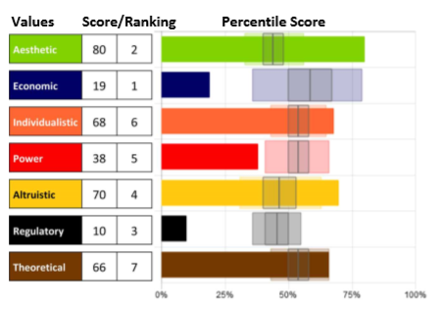

2) Language Changes
- The Political dimension will now be known as the Power dimension. It means the same in terms of motivation, but the descriptive word is much more relevant to the measurement of the dimension.
- The definition for Altruistic has been updated to “a drive to help others at the expense of self” to bring further clarity to that definition.
- The five areas of focus on each of the Specific Dimension pages have been changed to: Universal Assets, Critical Advantages, Driving Intuitions, Learning Paths and Growth Opportunities providing extensive information and coaching opportunities.
- A few very minor adjustments to the Application sections.

3) Page Changes/Additions
- A Closer look at the Seven Motivator Dimension Scores provides a quick, but detailed, overview of each motivator, in their high and low scores, and how those dimensions are energized.
- The Individual descriptive statements and the scoring ranges from Very Low to Very High are now on their own page.

